**How to install or update java 17 on linux.**

Present java --version is 1.8

Now we update java --version 17 on this server.

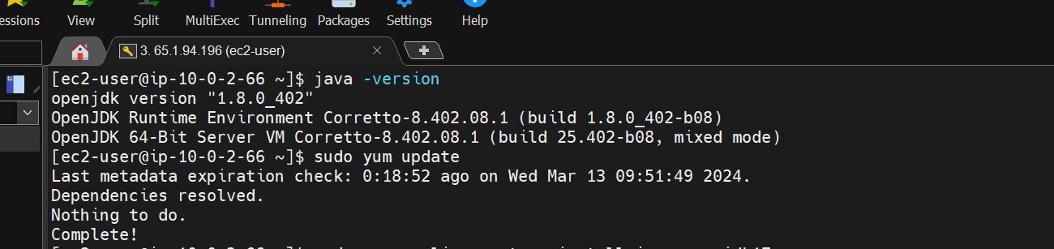

**Command :-** sudo yum install java-17-amazon-corretto-headless

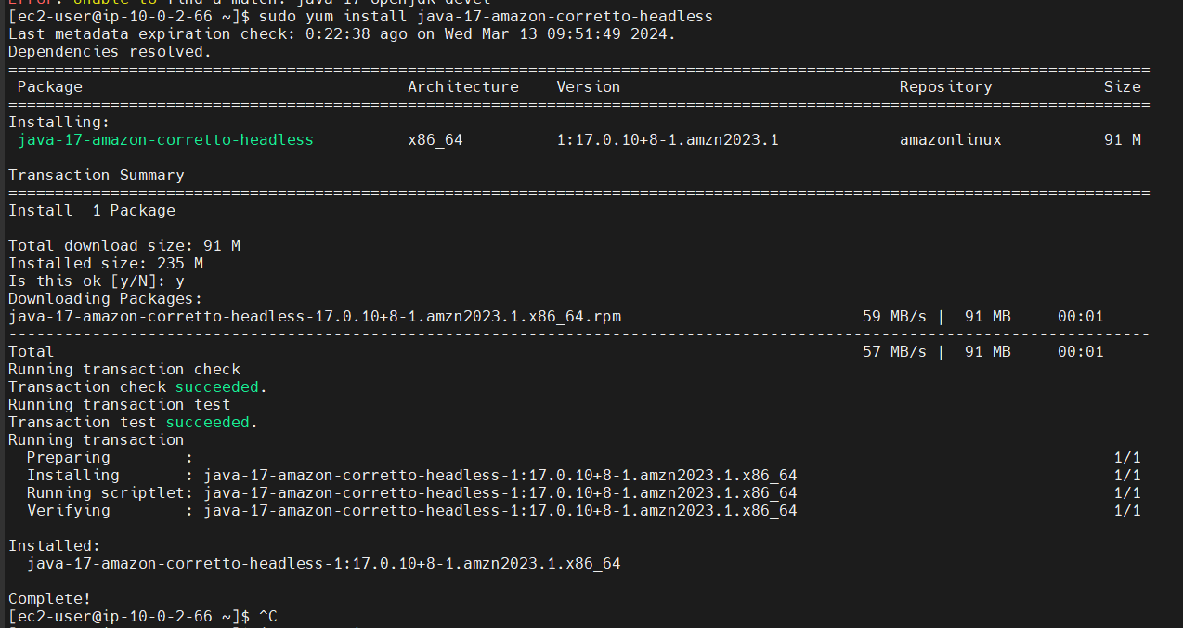

**Command :-** nano ~/.bashrc

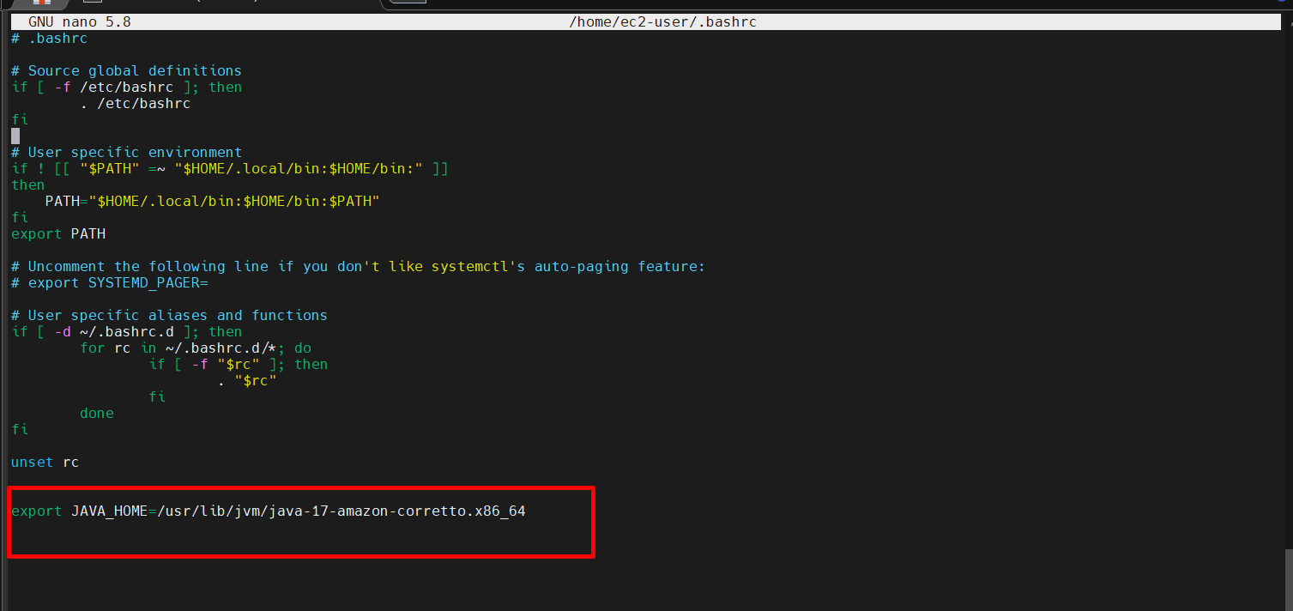

Save it that.

**Command :-**  source ~/.bashrc

This command is used for refresh or update the .bashrc file  
  
**command :-** echo $JAVA_HOME  
  
It is used show JAVA_HOME

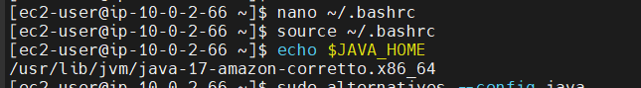

**Command:-** sudo alternatives --config java

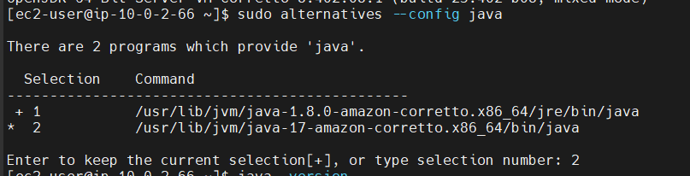

Now we check java version

**Command :-**

